Control structures and loops

Introduction to Control Structures
Control structures like if-else statements and switch cases are vital tools in programming. They allow developers to make decisions within their code. These structures control the flow of execution based on specific conditions, making programs more dynamic and responsive. This reading explores the purpose, syntax, and practical applications of if-else statements and switch cases, helping you understand how to use them effectively.

The Purpose of If-Else Statements
An if-else statement is a conditional construct that allows a program to decide whether a specific condition is true or false. When a condition is met (true), the program executes a block of code; if it is not met (false), it executes an alternative block. This structure is essential for scenarios where a binary choice must be made.

Example Use Case
Imagine writing a program that checks if a user is old enough to access a restricted section of a website. The program can grant or deny access based on the user's age. Access is granted if the user is aged 18 or above; otherwise, access is denied.

Syntax of If-Else Statements
In C#, the syntax for an if-else statement looks like this:
if (condition)
{ // Code to execute if the condition is true
}
else
{ // Code to execute if the condition is false
}
For example:
int age = 18;
if (age >= 18)
{ Console.WriteLine("Access granted.");
}
else
{
Console.WriteLine("Access denied.");
}
In this example, the program checks whether the age variable is 18 or older. If it is, the program prints "Access granted." If not, it prints "Access denied." This approach provides a simple way to handle decision-making based on a single condition.

The Purpose of Switch Cases
While if-else statements are effective for binary decisions, switch cases provide a more organized and readable way to handle multiple conditions. A switch statement evaluates a variable and executes different actions depending on its value. This is particularly useful when there are several possible outcomes.

Example Use Case
Consider a vending machine program that dispenses different drinks based on the button pressed by the user. Instead of using multiple if-else statements, a switch case can handle each button's action more efficiently.

Syntax of Switch Cases
The syntax for a switch case in C# is as follows:
switch (variable)
{
case value1:
// Code to execute if variable == value1
break;
case value2:
// Code to execute if variable == value2
break;
default:
// Code to execute if variable matches none of the cases
break;
}
For example:
string button = "Water";
switch (button)
{
case "Water":
Console.WriteLine("Dispensing water");
break;
case "Soda":
Console.WriteLine("Dispensing soda");
break;
default:
Console.WriteLine("Invalid option");
break;
}
In this example, the program checks the value of the button variable. If it matches "Water," the program prints "Dispensing water." If it matches "Soda," it prints "Dispensing soda." If the value does not match any case, the default case is executed, printing "Invalid option." This structure makes the code more readable and organized compared to using multiple if-else statements.

Applying If-Else Statements and Switch Cases to Solve Problems

Using If-Else Statements for Binary Decisions
If-else statements are best suited for scenarios where there are only two possible outcomes. For example, a program might check if a student's grade is above or below a passing mark. Here’s how an if-else statement can be used to determine and print whether a student has passed:
int grade = 55;
if (grade >= 50)
{
Console.WriteLine("Passed");
}
else
{
Console.WriteLine("Failed");
}
In this code, the program evaluates whether the grade variable is 50 or higher. If it is, "Passed" is printed; otherwise, "Failed" is printed. This approach provides a straightforward method for managing decisions that hinge on a single condition.

Using Switch Cases for Multiple Conditions
Switch cases are ideal for handling situations where a variable has several possible values, and each value requires a different response. For example, in a grading system that assigns a letter grade based on a student’s score, a switch case simplifies the decision-making process:
int score = 85;
switch (score / 10)
{ case 10:
case 9:
Console.WriteLine("A");
break;
case 8:
Console.WriteLine("B");
break;
case 7:
Console.WriteLine("C");
break;
default:
Console.WriteLine("F");
break;
}
Here, the program evaluates the result of dividing the score by 10. This helps determine which range the score falls into, assigning the appropriate grade from "A" to "F." The use of break statements ensures that once the correct case is matched, no other cases are checked. This method is efficient and clear, making it easier to manage multiple possible outcomes.

Practical Implementation of Control Structures
This reading covers advanced uses of nested and chained if-else statements, complex switch statements, and their applications in real-world scenarios.

Nested If-Else Statements
Nested if-else statements handle complex decisions by placing one if-else inside another. This approach is useful when actions depend on multiple conditions. For example, a store may offer discounts based on the total purchase amount and customer membership. The program first checks the purchase amount; if it meets a threshold, it checks membership to apply an additional discount.
However, overusing nested if-else statements can create difficult-to-maintain "spaghetti code." Use them only when necessary to manage dependent conditions.

Chained If-Else Statements
Chained if-else statements are better suited for multiple mutually exclusive conditions. They check each condition sequentially, keeping the code readable and organized. For instance, a program that calculates shipping costs based on location first checks if the location is "local," then "domestic," and so on. This method is efficient when conditions are independent.

Tips to Avoid Spaghetti Code:
- Simplify conditions into smaller parts.
- Encapsulate logic in functions.
- Add comments to explain the purpose of each condition.

Complex Switch Statements
Switch statements handle multiple conditions efficiently based on a single variable’s value, making them ideal for cases with many possible outcomes.

Combining Multiple Cases
When different cases require the same action, such as "Monday" and "Wednesday" sharing a food recommendation, they can be combined in a switch statement to avoid redundancy:
switch (day) {
case "Monday":
case "Wednesday":
Console.WriteLine("Eat cereal");
break;
}

Pattern Matching
Switch statements can use pattern matching to handle inputs that meet specific criteria, such as checking if a string contains "jazz" or "rock" and responding accordingly.

Default Case
The default case manages any input that doesn’t match specified cases, ensuring the program handles unexpected values gracefully, such as applying standard shipping when no location matches predefined cases.

Applications in Real-World Scenarios
Control structures like if-else statements and switch cases are crucial for practical programming tasks:

Inventory Management
Use if-else to decide whether to reorder a product based on stock levels:
if (stockLevel < reorderThreshold) {
reorderProduct();
} else {
maintainCurrentStock();
}

Order Processing
Use switch to determine the shipping method based on customer location:
switch (location) {
case "local":
applyLocalShipping();
break;
case "domestic":
applyDomesticShipping();
break;
case "international":
applyInternationalShipping();
break;
default:
applyStandardShipping();
break;
}

Discount Application
Use nested if-else to apply discounts based on purchase amount and membership:
if (totalAmount > 100) {
if (isMember) applyMemberDiscount();
else applyRegularDiscount();
} else {
applyNoDiscount();
}

Acitivity – Implementing control structures

Full Example 1: Advanced If-Else Statements – Tax Calculation System

Problem Statement:
You are tasked with developing a tax calculation system. The program must calculate the tax rate based on the user's income and whether they are a resident or a non-resident. The tax rates are as follows:
- If the income is less than $50,000, residents are taxed at 10%, and non-residents at 15%.
- If the income is between $50,000 and $100,000, residents are taxed at 20%, and non-residents at 25%.
- If the income is over $100,000, residents are taxed at 30%, and non-residents at 35%.

Step-by-Step Code Construction with Syntax Explanation:
Step 1: Start with the Primary Condition
if (income < 50000) {
Explanation:
- if: This is the basic if-statement that evaluates a condition. If the condition inside the parentheses is true, the code inside the block {} will execute.
- income < 50000: This is a comparison operator. It checks whether the value of income is less than 50,000. If this condition is true, it moves to the next step inside the block.
- { }: Curly braces enclose the block of code that runs when the condition is true.
In this case, the condition is asking: "Is the income less than $50,000?"
Step 2: Add Nested If-Else to Check Residency if (isResident) { taxRate = 0.10; // 10% tax for residents } else { taxRate = 0.15; // 15% tax for non-residents }
Explanation:
- isResident: This is a boolean variable. It holds either true or false. In this case, if the user is a resident, isResident will be true.
- if (isResident): We are checking if isResident is true. If it is, the tax rate for residents (10%) will be applied.
- taxRate = 0.10;: The equal sign = is the assignment operator. It assigns the value 0.10 (or 10%) to the variable taxRate.
- else: If the first condition (whether the user is a resident) is false, the program moves to the else block and applies the non-resident tax rate of 15%.
- taxRate = 0.15;: This assigns the value 0.15 (or 15%) to taxRate for non-residents.
- This structure lets the program decide between two outcomes: one for residents and another for non-residents.
Step 3: Handle the Next Income Bracket
} else if (income >= 50000 && income <= 100000) { if (isResident) { taxRate = 0.20; // 20% tax for residents } else { taxRate = 0.25; // 25% tax for non-residents } }
Explanation:
- else if: This keyword is used when we need to check another condition if the first if condition is false. This means if the income is not less than $50,000, the program will now check if the income is between $50,000 and $100,000.
- income >= 50000 && income <= 100000: This is a logical condition. It uses the greater than or equal to operator (>=) and the less than or equal to operator (<=) to check if the income falls between $50,000 and $100,000. The && operator means both conditions must be true.
- The same logic is followed for checking residency inside this block:
- if (isResident): Checks if the user is a resident. If true, assign the resident tax rate of 20% using taxRate = 0.20;.
- else: If the user is not a resident, the program assigns the non-resident tax rate of 25% using taxRate = 0.25;.
Step 4: Handle the Final Income Bracket
} else { if (isResident) { taxRate = 0.30; // 30% tax for residents } else { taxRate = 0.35; // 35% tax for non-residents } }
Explanation:
- else: This is the final fallback for the last possible outcome. It doesn't need a condition because, by process of elimination, it handles all income values that are above $100,000.
- We again nest an if-else block to check for residency:
- If the user is a resident (isResident is true), they will get a tax rate of 30%.
- If the user is not a resident (isResident is false), they will get a tax rate of 35%.
Step 5: Calculate and Print the Tax
tax = income * taxRate; Console.WriteLine("The tax is: $" + tax);
Explanation:
- tax = income * taxRate;: This statement uses the multiplication operator (*) to calculate the tax by multiplying the user's income by the tax rate.
- System.Console.WriteLine: This function prints output to the console. In this case, it prints the calculated tax with a message.
Step 6: Run the code
Now we have built the full code to work with the tax. If you would like to run the code below, visit Dot Net Fiddle, delete the code on the page, paste the code below into the left hand side, and select run. Try different variations of Income and Residency to see how the code works.
- Input 45000 and Yes, then select Run
- Input 75000 and No, then select Run
User Input: The program asks the user to input their income and whether they are a resident.
- Console.ReadLine(): Reads the user input as a string.
- Convert.ToDouble(Console.ReadLine()): Converts the input string to a double, so we can perform numeric operations like multiplication.
- bool isResident = residentInput.ToLower() == "yes";: Converts the user's "yes" or "no" input into a boolean value.
Logic Execution: The logic remains the same as before, but now the values come from the user.
using System;

public class Program {
public static void Main() {
// Step 1: Prompt the user for input
Console.WriteLine("Enter your income:");
double income = Convert.ToDouble(Console.ReadLine());

Console.WriteLine("Are you a resident? (yes/no):");
string residentInput = Console.ReadLine();
bool isResident = residentInput.ToLower() == "yes";

double taxRate = 0;
double tax;

// Step 2: Use advanced if-else statements to calculate tax
if (income < 50000) {
if (isResident) {
taxRate = 0.10; // 10% tax for residents
} else {
taxRate = 0.15; // 15% tax for non-residents
}
} else if (income >= 50000 && income <= 100000) {
if (isResident) {
taxRate = 0.20; // 20% tax for residents
} else {
taxRate = 0.25; // 25% tax for non-residents
}
} else {
if (isResident) {
taxRate = 0.30; // 30% tax for residents
} else {
taxRate = 0.35; // 35% tax for non-residents
}
}

// Step 3: Calculate and print the tax
tax = income * taxRate;
Console.WriteLine("The tax is: $" + tax);
}
}

Full Example 2: Complex Switch Cases – Phone Plan Selector

Problem Statement:
You are developing a program to help users choose a phone plan based on the amount of data they want and whether they need international calling. The available plans are:
- Basic Plan: 2GB of data, no international calling.
- Standard Plan: 5GB of data, no international calling.
- Premium Plan: 10GB of data, with international calling.
- Elite Plan: Unlimited data, with international calling.

Step-by-Step Code Construction with Syntax Explanation:
Step 1: Start with a Switch Based on Data Usage
switch (dataNeeds) {
Explanation:
- switch (dataNeeds): The switch statement evaluates a single variable (in this case, dataNeeds). The program compares the value of dataNeeds against a series of case labels.
- dataNeeds: This variable stores the amount of data the user is requesting. The switch will compare this value to the available plan options.
Step 2: Add Cases to Handle Data Ranges case 2: plan = "Basic Plan"; break;
Explanation:
- case 2: This case checks if the user requested 2GB of data. If this is true, the code in this block executes.
- plan = "Basic Plan";: This assigns the string "Basic Plan" to the variable plan. It means that the user qualifies for the Basic Plan.
- break;: This tells the program to exit the switch statement after executing this case. Without break, the program would continue to check the other cases, which is unnecessary once the correct plan is found.
case 5: plan = "Standard Plan"; break;
Explanation:
- case 5: This checks if the user requested 5GB of data. If this is true, the user is assigned the Standard Plan.
Step 3: Handle Premium and Unlimited Plans
case 10: if (wantsInternationalCalling) { plan = "Premium Plan"; } else { plan = "Standard Plan"; } break;
Explanation:
- case 10: This checks if the data requested is 10GB
- if (wantsInternationalCalling): Inside this case, we use an if statement to check if the user wants international calling. If true, they get the Premium Plan.
- else: If the user does not want international calling, they are assigned the Standard Plan.
- The break; statement exits the switch once the correct plan is selected.
case -1: plan = "Unlimited Plan"; break;
Explanation:
- case -1: Here, -1 is a placeholder to represent “unlimited” data. If the user requests unlimited data, they are assigned the Elite Plan.
- break: Exits the switch after assigning the Unlimited Plan.
Step 4: Default Case
default: plan = "Invalid data request"; break; }
Explanation:
- default: The default case acts as a fallback. If none of the other cases are true, this block will run. Here, it assigns "Invalid data request” to plan.
- break: Exits the switch statement after the default case.
Step 5: Run the code
Now we have built the full code to work with the tax. If you would like to run the code below, visit Dot Net Fiddle, delete existing code in the left-hand panel, paste the code below, and select run.
User Input: The program asks the user to enter their data usage (in GB) and whether they want international calling.
- Convert.ToDouble(Console.ReadLine()): Converts the input string into a numeric value (double) to perform conditional checks.
- bool wantsInternationalCalling = intlCallingInput.ToLower() == "yes";: Converts the user’s input into a boolean value to check for international calling.
Switch Case Logic: The switch evaluates the data usage entered by the user and selects the appropriate phone plan. Nested if-else checks whether the user wants international calling for specific plans.
using System;

public class Program {
public static void Main() {
// Step 1: Prompt the user for input
Console.WriteLine("Enter your data usage (in GB):");
double dataUsage = Convert.ToDouble(Console.ReadLine());

Console.WriteLine("Do you want international calling? (yes/no):");
string intlCallingInput = Console.ReadLine();
bool wantsInternationalCalling = intlCallingInput.ToLower() == "yes";

string plan = "";

// Step 2: Use switch statement to select the plan
switch (dataUsage) {
case 2:
plan = "Basic Plan";
Console.WriteLine("You are choosing the Basic Plan");
break;
case 5:
plan = "Standard Plan";
Console.WriteLine("You are choosing the Standard Plan");
break;

case 10:
if (wantsInternationalCalling) {
plan = "Premium Plan";
Console.WriteLine("You are choosing the Premium Plan with International Calling");
} else {
plan = "Standard Plan";
Console.WriteLine("You are choosing the Standard Plan");
}
break;

case -1:
plan = "Unlimited Plan";
Console.WriteLine("You are choosing the Unlimited Plan with International Calling");
break;

default:
Console.WriteLine("Invalid data request");
break;
}
}
}

Loop Constructs

Introduction to Essential Loop Constructs
Loops are fundamental control structures in programming that allow developers to execute a block of code multiple times, saving time and making code more efficient. This reading will explore three common loops: for loops, while loops, and do-while loops. We will examine their definitions, usage, and syntax with examples in C#.

For Loops
A for loop is a control flow statement that executes a block of code repeatedly for a specified number of times. It is particularly useful when the number of iterations is known beforehand. For example, you might use a for loop to process each item in an array or to perform a calculation a set number of times.
The syntax of a for loop includes four parts:
- Initialization: this part initializes the loop counter, typically by setting it to a starting value.
- Condition: before each iteration, the loop checks a condition. If the condition is true, the loop continues; if false, the loop stops.
- Increment/decrement: after each iteration, the loop counter is modified, usually by incrementing or decrementing.
- Code block: This section contains the code to be executed on each iteration.

Example in C#
for (int i = 0; i < 5; i++)
{
Console.WriteLine(i);
}
In this example, the loop initializes an integer variable i to 0. The condition i < 5 ensures that the loop runs as long as i is less than 5. The increment operation i++ increases the value of i by 1 after each iteration. The loop prints the value of i each time, resulting in the output: 0, 1, 2, 3, 4. For loops are commonly used when working with arrays or when a task must be performed a known number of times.

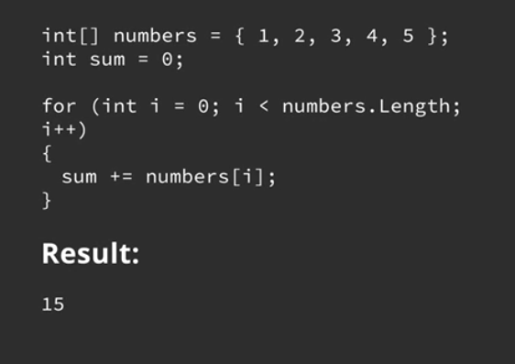

While Loops
A while loop is another control flow statement that allows code to be executed repeatedly based on a given condition. Unlike the for loop, a while loop is ideal when the number of iterations is unknown beforehand but depends on some condition that may change during execution. This makes while loops particularly useful for situations where you must keep acting until a certain condition is met, such as reading user input or continuously checking a sensor's status.
The syntax of a while loop is straightforward:
- It starts with the keyword while followed by a condition in parentheses.
- As long as the condition is true, the code block inside the loop is executed.

Example in C#
int counter = 0;
while (counter < 10)
{
Console.WriteLine(counter);
counter++;
}
Here, the while loop checks the condition counter < 10 before each iteration. If the condition is true, the loop executes the code block, which prints the current value of counter and then increments it by 1. The loop will continue running until counter is no longer less than 10, resulting in the output: 0, 1, 2, 3, 4, 5, 6, 7, 8, 9. This loop type is perfect for situations where the loop must continue running until a dynamic condition is met.
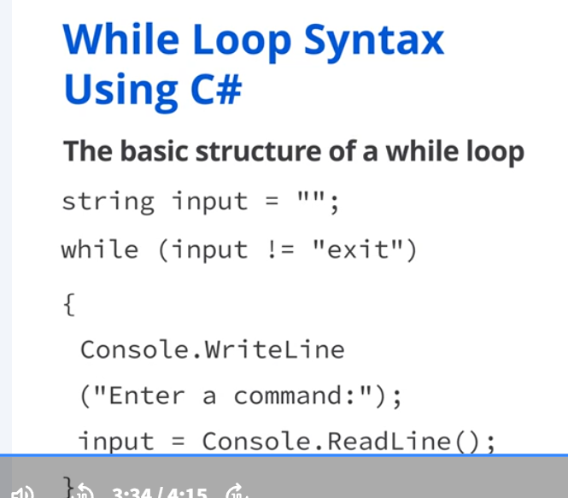

Do-While Loops
A do-while loop is similar to a while loop but with one crucial difference: it guarantees that the code block will execute at least once, regardless of the condition. This is because the condition is checked after the loop has been executed. The do-while loop ensures that an action occurs at least once before evaluating any conditions. Common use cases include prompting users for input until they provide valid data or initializing certain processes that must run at least once.
The syntax of a do-while loop involves two parts:
- The loop begins with the keyword do, followed by a code block enclosed in curly braces {}.
- After the code block, the keyword while and the condition are specified.

Example in C#
int counter = 10;
do {

Console.WriteLine(counter);
counter++;
}
while (counter < 10);
In this case, the loop prints the value of counter once before checking the condition counter < 10. Because counter is initialized to 10, the condition is false immediately after the first iteration. However, since the do-while loop checks the condition only after executing the code block, the number 10 is printed once before the loop exits. This behavior differentiates do-while loops from standard while loops: do-while loops always execute at least one iteration.

Comparing the Loops
Each type of loop serves a different purpose and is suited to different scenarios:
- For loops are best when the number of iterations is known ahead of time, such as when iterating over arrays or collections.
- While loops are ideal for situations where the number of iterations is not predetermined and depends on a condition that changes dynamically during execution.
- Do-while loops guarantee at least one execution, making them perfect for scenarios where you must run an action at least once before checking a condition.

Loop-Based Programming for Repetitive Tasks

Introduction
Loops are essential in programming to automate repetitive tasks. Loops can effectively manage program flow based on conditions when combined with control structures like if-else or switch statements. This reading explains how to use loops with these control structures, explores typical loop applications, and introduces techniques to optimize loop performance.

Combining Loops with Control Structures
Loops (for, while, do-while) can be combined with conditional statements to make decisions during repetitive tasks.

Loops with If-Else Statements
Using if-else statements inside loops allows a program to evaluate data and respond dynamically. For example, a for loop can iterate through an array of numbers, using an if-else statement to check if each number is even or odd (by evaluating whether the number is divisible by 2). This approach helps process data efficiently based on specific conditions.
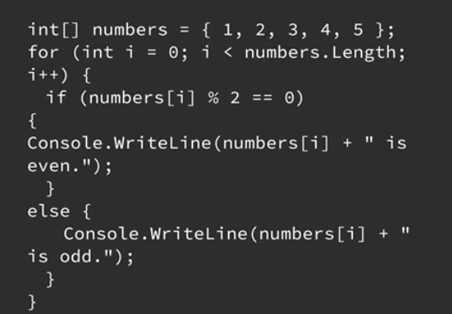

Loops with Switch Statements
Switch statements, when used with loops, provide an efficient way to handle multiple conditions. For instance, a loop can iterate over an array of weather forecasts, and a switch statement can handle different cases, such as "sunny," "rainy," or "cloudy," displaying a corresponding message for each condition. This method simplifies decision-making and reduces code complexity.
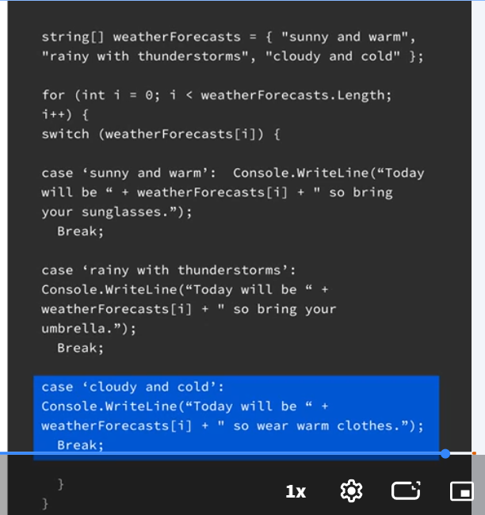

Common Applications of Loops
Loops are used in many programming tasks, from simple iterations to complex decision-making.

Iterating Through Arrays
Loops, particularly for loops, are ideal for iterating through collections like arrays. For example, a loop can traverse an array of prices, applying a calculation to each item, such as increasing all prices by a fixed percentage. This automates repetitive tasks, ensuring consistency and saving time.
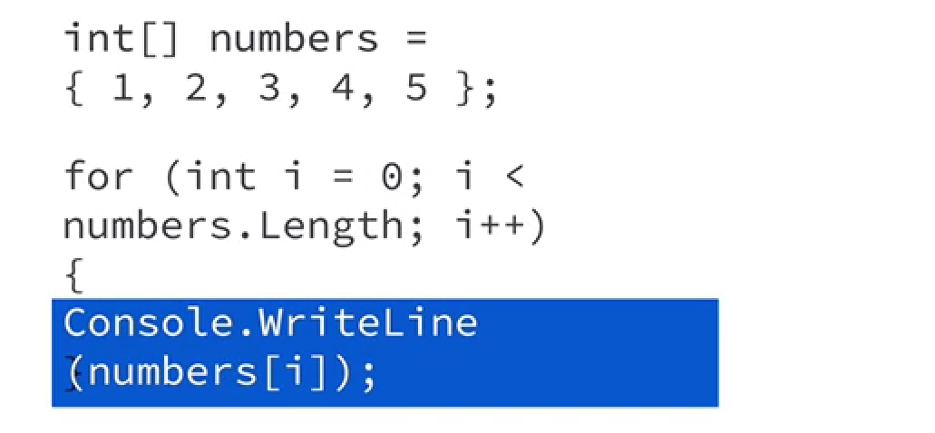

Generating Sequences
While loops are suitable for scenarios where the number of iterations is determined by a condition, such as generating numbers from 1 to 10, the loop continues as long as the specified condition is true, providing flexibility in handling dynamic tasks.
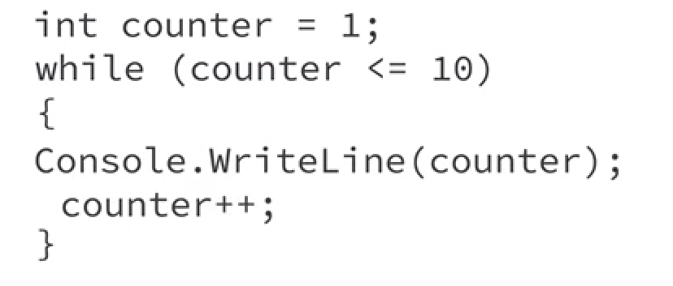

Ensuring At Least One Iteration
A do-while loop guarantees that a code block executes at least once before checking any condition. This is useful for tasks where an initial action, like prompting a user for input, must occur at least once, regardless of any conditions.
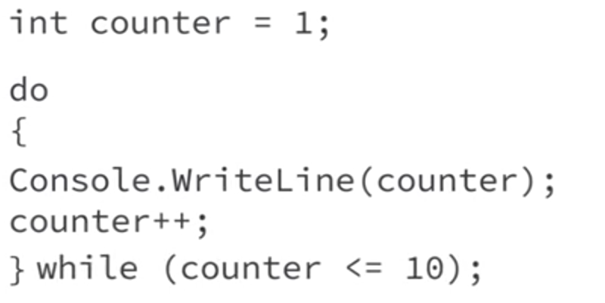

Optimizing Loop Performance
While loops are powerful, they can become performance bottlenecks if not optimized. Optimizing loops enhances a program’s speed and efficiency, especially when processing large datasets or performing complex calculations.

Why Optimize Loops?
Optimizing loops is crucial to preventing slowdowns caused by unnecessary iterations or redundant calculations. Efficient loops ensure faster execution, conserve resources, and improve application scalability.

Techniques for Optimizing Loops:
- Minimize iterations: use conditions to terminate loops early when a desired result is achieved, such as breaking out a loop once a target value is found.
- Avoid nested loops: minimize or restructure nested loops to reduce the total number of iterations, as nested loops can significantly increase execution time.

